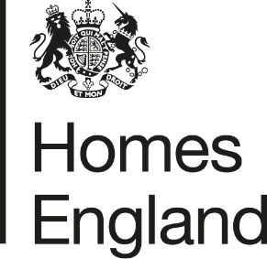
Making homes happen

CITY DEAL EXECUTIVE & STEWARDSHIP BOARD 3rd MARCH 2020
Homes England Quarterly Monitoring Progress Update Report
Quarter 3 2019 /20
- Report Overview
  - This report provides an update on the progress that has been made in relation to the Homes England sites that form part of the Preston, South Ribble and Lancashire City Deal. The update relates to the progress that has been made during the third quarter of 2019/20, between 1st October and 31st December 2019.
  - The report focuses on key delivery milestones, finances invested, and outputs generated, as well as providing a breakdown of the key risks and any emerging issues.
- Recommendation
  - Homes England recommends the Executive and Stewardship Board:
Note the content of this report and the progress made by Homes England during quarter 3 of 2019/20.
- Homes England Site Highlights
  - Good progress has continued to be made across Homes England’s sites between 1st October and 31st December 2019.
  - Key highlights from quarter 3 and the milestones forecast for quarter 4 are set out in the table below:
Phase / Plot | Status | Completions/  Total Units | Completions  (Oct – Dec) | Finance  (Oct – Dec) | Summary | Q4 Milestones
1. Cottam Hall
Phase 1 | Completed by Barratt Homes | 104 / 104 (100%) | Site Completed | n/a | This site has now completed build out. | n/a
Phase 2 | Story Homes on-site | 109 / 283 (38%) | 14 | n/a | Story Homes building out well, with 14 completions claimed within this reporting period. | Ongoing build out
Phase 3 | Unconditional deal with Morris Homes in place | 0 / 119  (0%) | n/a | n/a | Ongoing issues with newt trapping however a formal start on site was made by Morris Homes in January 2019. | Ongoing site preparation works and first completions now expected Q4
Phase 4 | Conditional deal with Rowland Homes in place | 0 / 141  (0%) | n/a | n/a | Reserved Matters Application for 141 homes was approved on 11th July 2019.  A great crested newt licence has been secured, however modification to this is required through Natural England and this process is taking some time. Homes England is also progressing resolution of the Section 106 agreement. | Deal to go unconditional and first contractual payment expected in Q1 20/21.
Phase 5 | Site not yet released. | 0 / 233  (0%) | n/a | n/a | Homes England determining disposal to SME developer(s) anticipated within 2020 / 21 | Update on disposal route.
Phase 6 (Plots 14 and 15) | Homes England continues to progress the disposal of Phase 6 (split between two  Plots 14 and 15):  Currently contracting with preferred developer (Countryside) on Plot 14 (68 units).  Marketing has been undertaken for Plot 15 (121 units) with four bids returned. | 0 / 189  (0%) | n/a | n/a | A Preferred Bidder has been identified for the western part of Phase 6 (Plot 14) with disposal of this parcel on an Unconditional Freehold Basis expected to complete in Q4.  The remainder of Phase 6 (Plot 15) has been marketed through Homes England Development Partner Panel (DPP3) during October through to December, with four bids received. | Disposal of Plot 14 expected to complete Q4.  On Plot 15 a preferred developer is to be selected from the four bidders and conditional contract to be complete by end of Q4.
2. Cottam Brickworks
n/a | Homes England re-commenced negotiations with the landowners agent (BXB) and LCC for past 12 months | 0 / 206  (0%) | n/a | n/a | Further information requested of BXB a number of times to inform the valuation appraisal process however not received to date and discussions have been fragmented at times. Further meeting and liaison between Homes England, LCC and the landowner’s have been held and discussions are ongoing to find a resolution to the sites access rights. | Homes England (working in collaboration with LCC) to review next steps and potential alternative approach to negotiation
3. Land at Eastway
Residential Plot | Story Homes on-site completing build out | 89 / 300  (30%) | 7 | n/a | Story Homes continues to build out, with 7 completions during this reporting period. Delivery of the Link Road is well underway with completion anticipated Q4. | Link road opening scheduled Q4
Commercial Plot | Site under conditional contract with HSB Healthcare | n/a | n/a | n/a | Homes England progressing the acquisition of community registered asset (CRA) land within the vicinity of the site.  This land is required to enable HSB Healthcare to deliver their scheme. | Site access to be delivered April – September 2020 before unconditional deal
4. Whittingham Hospital
Phase 1 | Taylor Wimpey has completed Phase 1 | 150 / 150 (100%) | n/a | n/a | Taylor Wimpey has completed build out of Phase 1. | n/a
Phase 2 | Preferred bidder has been selected subject to Homes England board approval | 0 / 232  (0%) | n/a | n/a | A preferred bidder has been selected following finalisation of tender process subject to Homes England board approval | Preferred bidder to be selected following finalisation of tender process subject to Homes England board approval and seeking to complete conditional contract in Q4.
Phases 3 and 4 | Not yet released. Disposal phases and options to be reviewed in 20/21. | n/a | n/a | n/a | n/a | n/a
5. Preston East
Expansion Area | Homes England is supporting further allocation of the site through the submission of a development statement to the Central Lancashire Local Plan review. | n/a | n/a | n/a | Homes England has prepared a Development Statement to promote the site for continued allocation within the Central Lancashire Local Plan. | Submission of representation to Central Lancashire Local Plan.
Sector D | Deal completed with Inchcape Estates now on site | n/a | n/a | n/a | Inchscape Estates continue development of site with construction underway. | Ongoing build out / near completion.
6. Pickerings Farm
n/a | Masterplan and outline application prepared | 0 / 345  (0%) | n/a | n/a | Finalisation of Masterplan and technical studies for submission as part of the outline planning application process. Ongoing detailed discussions and dialogue with SRBC. | Outline Planning Application submitted in Q4
7. Altcar Lane
n/a | Reserved Matters application approved | 21 / 200  (10%) | 21 | n/a | Lovell are ahead of programme and first completions achieved in quarter 3. | Ongoing build out
8. Croston Road North
n/a | Preferred Bidder (Keepmoat) approved October 2019 | 0 / 400  (0%) | n/a | n/a | Formal ITT was issued during March 2019 and bids were returned on 19th June. Home England approvals were obtained to proceed with a Preferred Bidder at the beginning of October 2019. | Conditional Contracts expected to be entered in to by the end of Q4 19/20.
9. Croston Road South
Phase 1 | Miller Homes has completed Phase 1 | 96 / 96 (100%) | 19 | n/a | Miller Homes has completed Phase 1 | Ongoing build out
Phase 2 | Miller Homes on-site | 62 / 79  (78%) | 13 | n/a | 13 completions have been recorded on Phase 2 of this site during this period. | Ongoing build out
10. Brindle Road
n/a | Complete | 46 / 46  (100%) | n/a | n/a | All units completed and all finances paid. | n/a
11. Walton Park Link
n/a | Morris on site | 0 / 275  (0%) | n/a | n/a | Morris commenced early site clearance works on site in September. Remediation work and construction of link road. | Ongoing site works and completions expected
- Finance
  - Homes England is currently on track to pay the majority of £37.5 million grant by 2023 / 24 however this position will be reviewed as part of the BDP Refresh (2020/21-2023/24).
  - No grant or loan payments were made to LCC during quarter 3 of 2019 / 20 due to ongoing contractual discussions prior to completion with Countryside Properties on Plot 14, Cottam Hall. These matters are to be finalised within Q4 which will see a loan and grant payment made in relation to Phase 6 (Plot 14) of Cottam Hall.
  - A loan amount of £2.8 million has now been moved out to the next financial year 2020 / 21 due to ecological matters and land take discussions for the PWD on Plots 1-3 with Rowland Homes.

- Summary of Delivery
  - Good progress has been made on site delivery across Homes England’s portfolio during quarter 3, with a grant and loan payment forecast to be paid to LCC within the final quarter of 2019 / 20. Key milestones have included:
    - A preferred bidder has been selected for the delivery of Phase 2 at Whittingham Hospital and
    - Miller Homes has completed build-out of Phase 1 at Croston Road South.
    - Lovell has started to complete initial delivery of homes at Altcar Lane
    - Taylor Wimpey has completed all build out and site works on Phase 1 at Whittingham Hospital and exited the site;
    - Build out and completion rates on Homes England sites have continued to increase within Q3. During the winter months particularly around Christmas time we would usually expect build out/sales rates to generally slow down and this is considered a normal pattern based on previous years and knowledge of the housing market across the country. However in this particular year (19/20), 74 new homes were completed in quarter 3 compared to 57 in quarter 2. This change in pattern could be specific to the 11 Homes England City Deal sites though, as the majority of these 11 sites (number of phases) are now building out with some phases fully completed during the last 2 quarters of 19/20. This is considered a very positive milestone and shows the ongoing/growing interest by a range of developers in the local housing market along with great progress being made on Homes England sites.
    - We expect build out and completion rates to increase further over the spring and summer months and particularly as we look towards the next 12-18 months as more Homes England’s sites/phases are disposed of to developers (as detailed in Section 3 of this report). Further consideration of build out rates across all City Deal site is to be considered by officers.
  - Due to the date of this report being presented, some of the milestones set out within Table 1 have been superseded. This will be formally documented in the quarter 4 report, however a summary of these include:
    - Selection of a preferred developer on Plot 15 at Cottam Hall, subject to board approval;
    - Outline planning consent achieved at Whittingham Hospital, subject to a Section 106 agreement;
    - Completion of the Link Road at Eastway, Preston;
    - Submission of an outline application on Pickering’s Farm; and
    - Selection of a preferred developer for Whittingham Phase 2, subject to board approval.

Summary of BDP Payments |  |  |  | BDP Forecast 2019 / 20
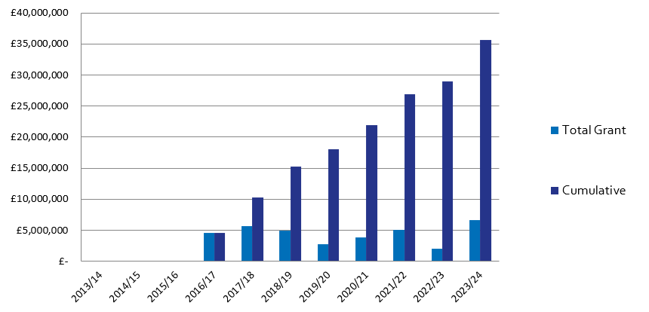
 |  |  |  |  | Q1 | Q2 |  | Q3 |  | In Year Actual | Revised BDP Forecast for Year
 |  |  |  | Grant | £0 | £2.000,000 |  | £0 |  | £0 | £2,000,000  £429k
 |  |  |  | Loan | £0 | £0 |  | £0 |  | £0 | £1,153,000
 |  |  |  | Housing Completions | 33 | 57 |  | 74 |  | 164 | 252
Planning Consents |  | Starts on Site |  | Housing Completions |  |  |  |  | Grant Payments
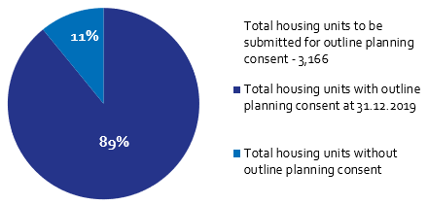 |  | 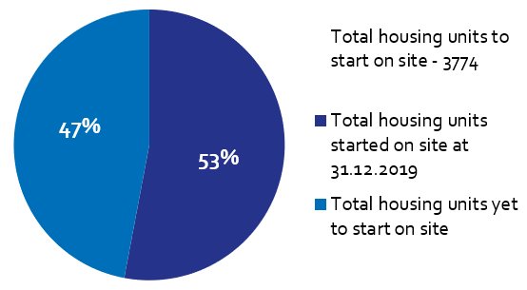 |  | 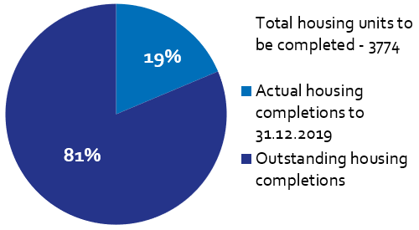 |  |  |  |  | 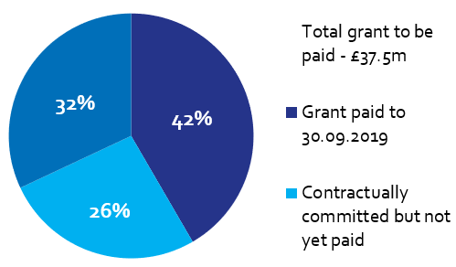
Of the Homes England residential City Deal sites, only Pickering’s Farm is yet to achieve planning consent.  This is due to be submitted in the final quarter of 2019 / 20. |  | Housing starts have been claimed for 1,678 units on Homes England City Deal sites to date. During this reporting period 21 new starts on site have been recorded.  Starts are claimed in full upon commencement of the site. |  | There have been 704 housing completions to date on Homes England City Deal sites.  There were 74 housing completions during this reporting period. |  |  |  |  | To date, £15,605,975 has been paid to LCC as grant, with a further £10m contractually committed to be paid upon receipt of annual payments on completed disposals.  No payments were made during Q3 2019/20.

